Puppy Raising Department
Ruff Notes
Love is in the Air: Raising an Intact Puppy
February 2022

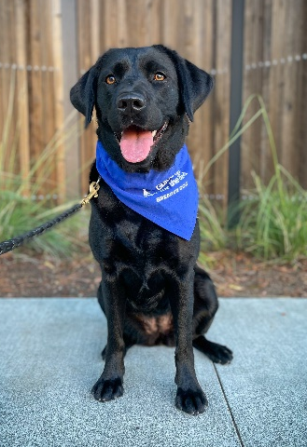
Love is in the air this Valentine’s Day and if you have an intact GDB puppy, you may have noticed some differences between the puppy you are raising and their altered friends. Raising an intact dog is rewarding and can come with some potential challenges. Our breeder dogs play a vital role in achieving our mission at GDB. Let’s spread the love about some of the qualities that are unique to intact dogs and the care that goes into making breeding magic.

“The Power of Love”
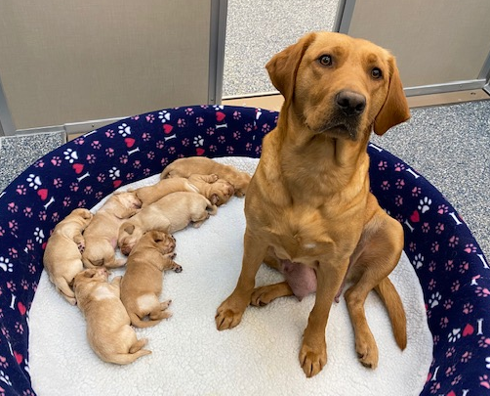
There are so many rewarding benefits when raising an intact dog, both when they’re in the puppy raising home and when they are selected as a breeder! An intact dog is typically recalled earlier than an altered dog, usually around 15 months of age.

If the dog you raised is selected as a breeder, you have the opportunity to raise one of their pups, adoringly called a “grand-puppy”. Additionally, when the breeder has puppies, you will receive regular video and picture updates while the puppies are in the whelping kennel. If available, you may come to meet the pups prior to them leaving campus to go into their puppy raising homes. Since our guide dog puppies are raised in 10 different states, you might see the offspring of the breeder you raised in many different places!

Guide Dogs for the Blind also works closely with other service dog organizations and occasionally cooperatively breeds, or donates, our intact dogs to support their mission. The pup you raised could be producing future heroes for other service dog organizations too!

Do you have a proclivity for naming dogs? If so - raising a breeder dog might be for you! Raisers whose pups go on to be breeders have the chance to offer name suggestions for their grand-puppies!

“Love on the Brain”: Behaviors of Intact Dogs

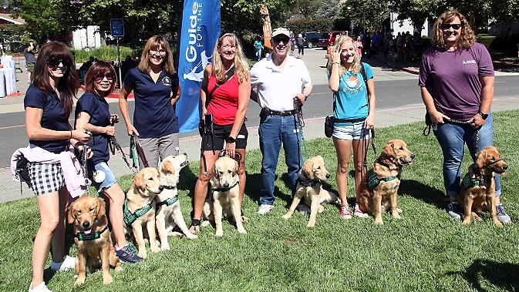
When raising an intact dog, you may notice a few behaviors that might show up “Time After Time” as they mature. Although not all intact dogs present these behaviors, it’s important to keep an eye out for these common hormonal behaviors:
- Increased dog distraction
- Increased scent distraction
- Attempts to mark on walks
- Door rushing when going outside
- Investigative and hormonal behavior with pet dogs in the household

NOTE: If the intact dog that you’re raising presents any of the above behaviors, be sure to reach out to your leader and CFR for support.

“All the Single Ladies”: Caring for Intact Female Dogs

When raising intact female dogs, there are several behavioral and physical changes that you may notice as she is going into season.

Prior to a female dog entering a season, you may notice anatomical changes and increased licking to their nether regions. You may also see some regression in behaviors that she was doing well in previously, including poor house behavior and avoidance of control. Additionally, some females display uncharacteristic fearful behavior starting a few weeks before their season. This may be a good time to limit socialization and keep outings lowkey.

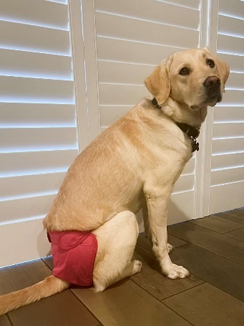
During the approximate 21-28 days that she is in season, you may notice the intact female that you’re raising become more affectionate to you or other members of the household. Her energy levels may also change, including more frequent naps and/or becoming less active. For more information on keeping intact females in season, be sure to review the Guidelines for Boarding Females in Season.

An intact female staying home during her season doesn’t have to be bored! Here are some fun activities to do while she is housebound.

NOTE: Although intact male dogs may have hormonal differences compared to their altered counterparts, in general, their care is not much different than an altered dog.

“I Don’t Want to Miss a Thing”: Rules for Intact Puppies

Although there are many similarities when raising both intact and altered dogs, there are a few policies to keep in mind when raising potential breeders for GDB:
- Female dogs in season should be kept separately from intact male dogs
- Females in season should be kept indoors and not be socialized in public
- Do not leave female dogs in season unattended in a yard
- If an intact dog (or any dog) gets loose from your home, immediately contact your leader and GDB’s emergency number for assistance

If you’re interested in raising an intact dog, but don’t have the resources to keep an intact female in season, reach out to your leader to see what options are available. It takes a village to raise successful guide dog puppies!

